Friday 12th March 2021



Dear Parents and Carers,

On Friday 19th March it is Red Nose Day.

Please come dressed in RED on Friday and bring a £1 donation.

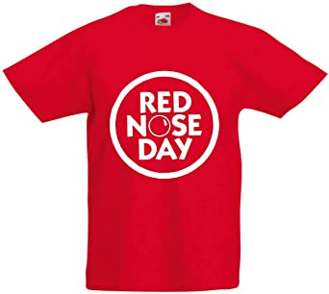

Yours Sincerely,

The SPAH Team

