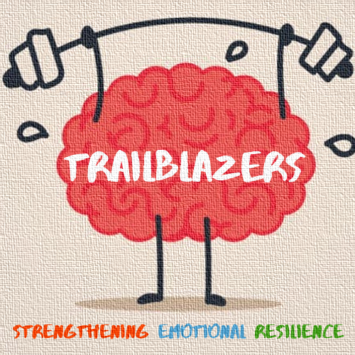
Coffee Morning

Come & join the Trailblazers on
Date: 18th March
Time: 09:15
St Paul’s & All Hallows School

Trailblazers are a partnership made up of Mental Health Support Teams in schools and other wellbeing services. We work within Haringey schools to support the emotional wellbeing of children, young people, parents and staff. We want to hear from you and your ideas on how we can best support you and your school.
We will be joined by Billie-Claire Wright
We look forward to seeing you there!!

